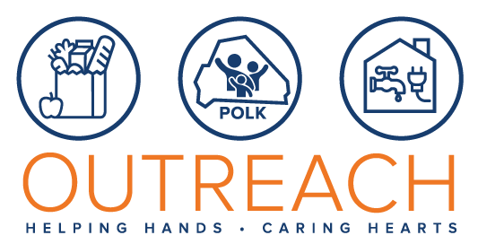
Donation Ideas
Cereal
Cake Mix
Pancake mix
Muffin Mix
Syrup
Canned chicken
Canned tuna
Sugar (1lb Bags)
Oil
Chicken Breasts
Rolls of Ground Beef (1lb)
Juice
Salad Dressing
Fresh Produce
Baby Formula
Adult Incontinence Pull-Ups
Toothpaste (adult & children)
Baby Bottles
Shampoo (adult, children & infant)

